**Appendix**

The following supplementary information details the specific parameters defined in the Rytary and Sinemet schematics. Models were created using MATLAB 2022b SimBiology software.

**Figure 9**. Schematic of levodopa flow for Rytary. Nodes represent reaction kinetics.

*Descriptions for each element in the Rytary schematic:*

**Table 1.** Dose schedule for Rytary (levodopa amount). Time intervals are in hours and dosage is in mg. Rate is defined as 0 for each interval as it is decided by the schematic.

**Table 2.** Initial dose of levodopa, initial concentration of levodopa in the periphery, and rate of absorption of levodopa in the periphery, respectively (100% of the dosage is absorbed into the periphery in 1 hour, consistent with experimental findings).



**Table 3**. Initial concentration of levodopa in the periphery and rate of elimination of levodopa (arbitrarily chosen), physiologically equivalent to the rate of conversion to dopamine in the periphery.



**Table 4.** Initial concentrations of levodopa in the periphery and CNS and the rate of diffusion of levodopa across the BBB (Only ~1% of levodopa crosses the BBB; however, this was neglected to better visualize dynamics in the simulation).



**Table 5.** Initial concentration of levodopa in the CNS and rate of elimination of levodopa due to conversion to usable dopamine. The rate was arbitrarily chosen but equal to the Sinemet model.



**Table 6.** Initial concentration of levodopa in the CNS and the rate of elimination of levodopa via enzymatic breakdown of levodopa by COMT. The general elimination rate of Rytary is 2.5x slower than Sinemet as found experimentally.



**Figure 10**. Schematic of levodopa flow for Sinemet. Nodes represent reaction kinetics.

*Descriptions for each element in the Sinemet schematic:*

**Table 7.** Dose schedule for Sinemet (levodopa amount). Time intervals are in hours and dosage is in mg. Rate is defined as 0 for each interval as it is decided by the schematic.

**Table 8.** Initial dose of levodopa, initial concentration of levodopa in the periphery, and rate of absorption of levodopa in the periphery, respectively (100% of the dosage is absorbed into the periphery in 1.5 hours, consistent with experimental findings).



**Table 9**. Initial concentration of levodopa in the periphery and rate of elimination of levodopa (arbitrarily chosen), physiologically equivalent to the rate of conversion to dopamine in the periphery.



**Table 10.** Initial concentrations of levodopa in the periphery and CNS and the rate of diffusion of levodopa across the BBB (Only ~1% of levodopa crosses the BBB; however, this was neglected to better visualize dynamics in the simulation).



**Table 11.** Initial concentration of levodopa in the CNS and rate of elimination of levodopa due to conversion to usable dopamine. The rate was arbitrarily chosen but equal to the Sinemet model.



**Table 12.** Initial concentration of levodopa in the CNS and the rate of elimination of levodopa via enzymatic breakdown of levodopa by COMT. The elimination rate of Sinemet is 2.5x faster than Rytary as found experimentally.



The schematics and parameters for the generalized carbidopa and Entacapone metabolic reactions are outlined below. These models show how the inhibitory actions of the drugs affect levodopa/dopamine availability. Reaction rates are arbitrarily chosen but can be replaced with values that reflect actual metabolic reaction kinetics based on experimental findings.

**Figure 11.** Schematic for levodopa to dopamine conversion, with and without carbidopa.

**Table 13.** Initial doses for levodopa and dopamine without carbidopa added to the system, and the forward reaction rate, all chosen arbitrarily. Units are irrelevant for this simplified model but are necessary for biologically accurate models.



**Table 14.** Initial doses for levodopa and dopamine with carbidopa added to the system, and the forward and reverse reaction rates, all chosen arbitrarily (kf_1 = forward; kr = reverse). Units are irrelevant for this simplified model but are necessary for biologically accurate models. The reverse reaction represents the kinetics of dopamine inhibition via carbidopa

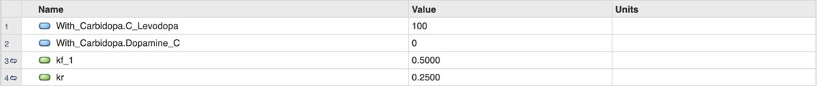

**Figure 12.** Schematic for the enzymatic reaction of levodopa, COMT and COMT inhibitor, with and without Entacapone.

**Table 15.** Initial doses for levodopa, COMT, and 3-O-methyldopa with Entacapone, and the reaction rate, kf. Values are arbitrarily chosen, and units are irrelevant for this relative model but are necessary for biologically accurate models.

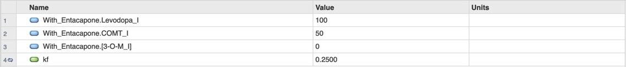

**Table 16.** Initial doses for levodopa, COMT, and 3-O-methyldopa with Entacapone, and the reaction rate, kf_1. Values are arbitrarily chosen, and units are irrelevant for this relative model but are necessary for biologically accurate models.

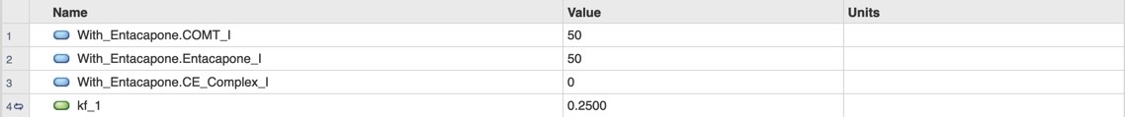

**Table 17.** Initial doses for levodopa, COMT, and 3-O-methyldopa without Entacapone, and the reaction rate, kf_2. Values are arbitrarily chosen, and units are irrelevant for this relative model but are necessary for biologically accurate models.

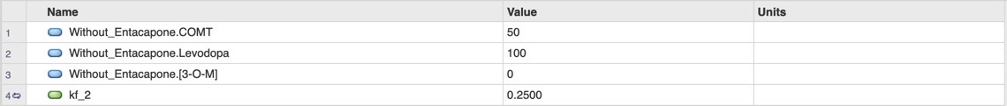

To view and analyze each model in SimBiology, run the code in MATLAB and then open up the SimBiology Model Builder application (you may be prompted to install SimBiology when trying to run the code in MATLAB). Next, open up the SimBiology Model Analyzer application from the builder app and follow the steps in the following figures to graph the dynamics.

**Figure 13.** Import the code from MATLAB in the SimBiology Model Builder App.

**Figure 14.** Open the SimBiology Model Analyzer App and choose click “Program” to open the model associated with the schematic made in the SimBiology Model Builder App. Select the model to run and click “Run.”

**Figure 15.** To run and overlay multiple models, select, “Keep results from each run.” To only view certain data, simply select/deselect the responses desired.